* 1. 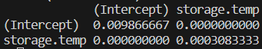

It should be called a prediction interval. Confidence intervals refer to the uncertainty of where the true regression line (representing the mean of y) falls. We use prediction intervals to predict future observations.

* 1. 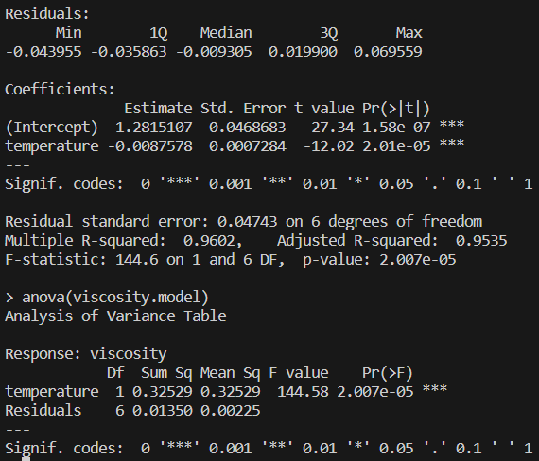

; We reject the null hypothesis, there is evidence that the viscosity of toluene-tetralin blends is related to the temperature of the blends. Furthermore, $R^{2}=0.9602$ suggests that this model accounts for a high percentage of the variability in y.

* 1. 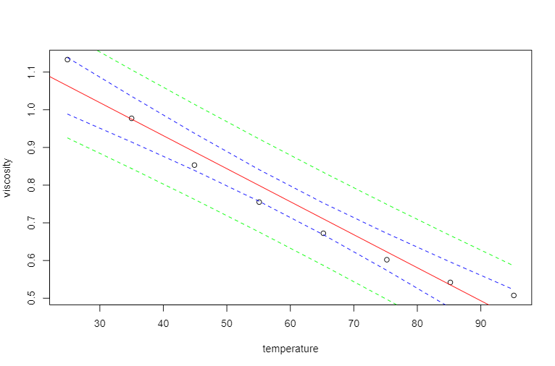
  2. ; We reject the null hypothesis, there is evidence to suggest that there is a relationship between the amount that a company spends on advertising and audience members’ retained impressions.
  3. 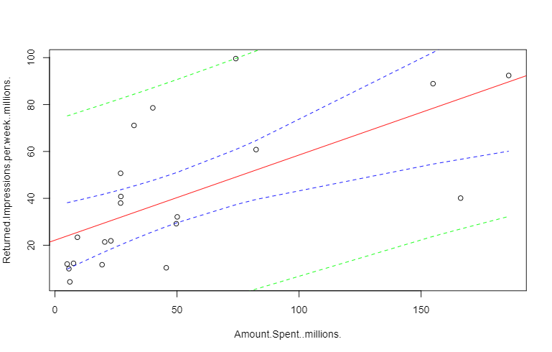
  4. 95% CI [20.183, 43.681]

95% PI [-18.641, 82.505]